Bahria University,

Karachi Campus



LAB EXPERIMENT NO.

**02**

LIST OF TASKS

|  |  |
| --- | --- |
| TASK NO | OBJECTIVE |
| 1 | **Developing and running application.**   * + **Configuring Android Device to run application.**     - **Android Virtual Device.**       * **Creating, Starting, Stopping, Docking etc.**     - **Using ADB**       * **Enabling developer options.**       * **Enabling USB debugging within developer options.**       * **Listing attached devices from command prompt.**       * **USB debugging authorizations on device.**       * **Attaching device within network.** |
| 2 | **Running a template-based application on device.** |
|  |  |

**Task 1: Developing and running application.**

* + **Configuring Android Device to run application.**
    - **Android Virtual Device.**
      * **Creating, Starting, Stopping, Docking etc.**
    - **Using ADB**
      * **Enabling developer options.**
      * **Enabling USB debugging within developer options.**
      * **Listing attached devices from command prompt.**
      * **USB debugging authorizations on device.**
      * **Attaching device within network.**

**Solution**

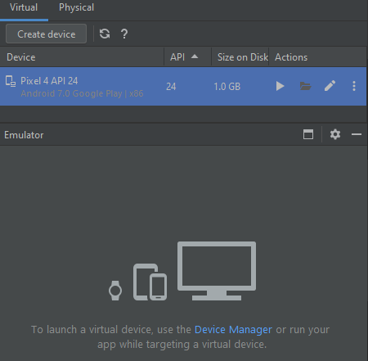

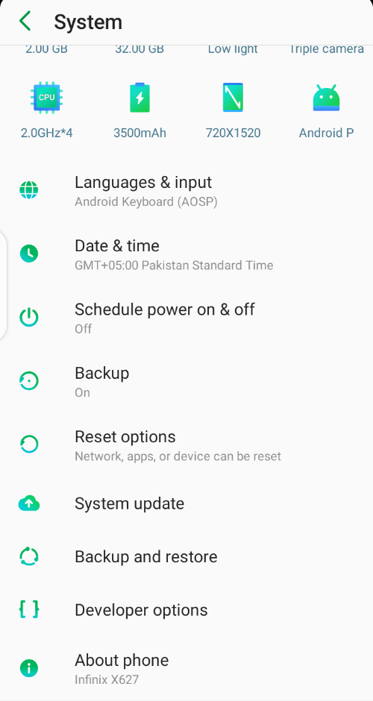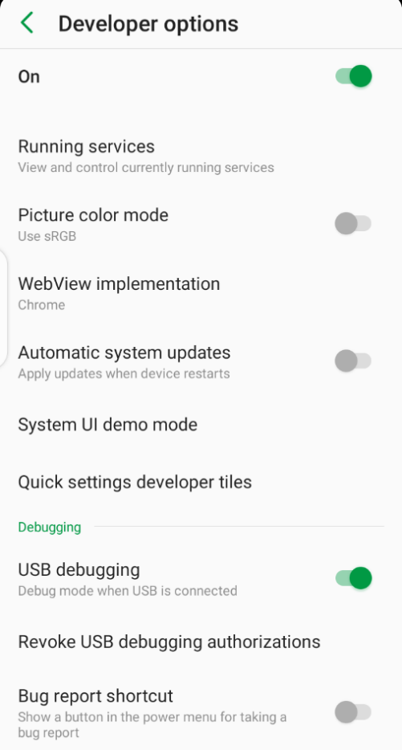

**Task 2: Running a template-based application on device.**

**Solution:**

